AWS S3

Amazon Simple Storage Services – AWS S3

Case Study



**Amazon S3**

Step by step tutorial for using AWS S3

**Step 1) Sign Up.**

1. Sign up for the AWS Management console
2. Login to your AWS account and go to the AWS Services tab at the top left corner.
3. Here, you will see all of the AWS Services categorized as per their area viz. Compute, Storage, Database, etc. For creating an S3 Bucket, we have to choose Storage as in the next step.

1. Open all the services and click on S3 under Storage services. This will launch the dashboard of S3. Here is the S3 dashboard. Here you will get all the information in gist about the AWS EC2 resources running.

AWS dashboard look like this

**Step 2) Create Bucket**

Click on the “Create bucket” button to create an S3 bucket. When you press the “Create bucket” button, the screen appears below:

1. Name the Bucket - Bucket name must be unique and must not contain spaces or uppercase letters.
2. Configure Opetional-

You can pick the features that you want to activate on a specific bucket, such as:

* Tags: You can tag a bucket with a key and a name that will make it easier to search for resources with tags.
* Versioning: Keep track of all versions of the file, making it easy to retrieve the file in accidental deletion.
* Object-level logging (Advanced Setting): Activate this function if you want to record any operation for any item in your bucket.
* Default encryption: By default, AWS encrypts files via AES 256 with generated keys, but you can use your own managed key to encrypt items.

Finally, click on “Create bucket”

Your Bucket is created

**Step 3) Upload Object in created bucket**.

We will learn how to upload object on s3 bucket.

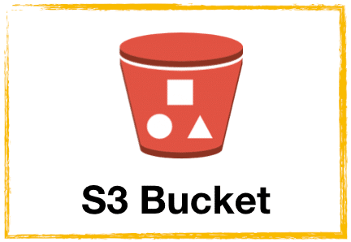

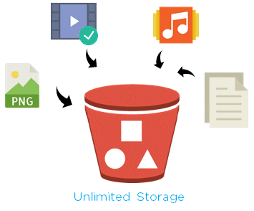

**1. Click on Bucket Name**

**2. Click on Upload**

**3. Click on Add files**

Select file of data needs to be uploaded. Like csv or images, etc

**4. Click on Upload**

We observe that our document uploads to the newly created bucket from the above screen.

**Step 4) Download Object from created bucket**.

1. In the **Buckets** list, choose the name of the bucket that you want to download an object from.
2. You can download an object from an S3 bucket in any of the following ways:
   1. Select the object and choose **Download** or choose **Download as** from the **Actions** menu if you want to download the object to a specific folder.
   2. If you want to download a specific version of the object, select the **Show versions** button. Select the version of the object that you want and choose **Download** or choose **Download as** from the **Actions** menu if you want to download the object to a specific folder.

You've successfully downloaded your object.

**Step 5) Copy an object to a folder**

You've already added an object to a bucket and downloaded the object. Now, you create a folder and copy the object and paste it into the folder.

**To copy an object to a folder**

1. In the **Buckets** list, choose your bucket name.
2. Choose **Create folder** and configure a new folder:
   1. Enter a folder name (for example, favorite-pics).
   2. For the folder encryption setting, choose **None**.
   3. Choose **Save**.

1. Navigate to the Amazon S3 bucket or folder that contains the objects that you want to copy.
2. Select the check box to the left of the names of the objects that you want to copy.
3. Choose **Actions** and choose **Copy** from the list of options that appears.

Alternatively, choose **Copy** from the options in the upper right.

1. Choose the destination folder:
   1. Choose **Browse S3**.
   2. Choose the option button to the left of the folder name.

To navigate into a folder and choose a subfolder as your destination, choose the folder name.

* 1. Choose **Choose destination**.

The path to your destination folder appears in the **Destination** box. In **Destination**, you can alternately enter your destination path, for example, s3://*bucket-name*/*folder-name*/.

1. In the bottom right, choose **Copy**.

Amazon S3 moves your objects to the destination folder.

**Step 6) Delete Object and Bucket**

**Deleting an object**

If you want to choose which objects you delete without emptying all the objects from your bucket, you can delete an object.

1. In the **Buckets** list, choose the name of the bucket that you want to delete an object from.
2. Select the check box to the left of the names of the objects that you want to delete.
3. Choose **Actions** and choose **Delete** from the list of options that appears.

Alternatively, choose **Delete** from the options in the upper right.

1. Type **permanently delete** if asked to confirm that you want to delete these objects.
2. Choose **Delete objects** in the bottom right and Amazon S3 deletes the specified objects.

**Emptying your bucket**

If you plan to delete your bucket, you must first empty your bucket, which deletes all the objects in the bucket.

**To empty a bucket**

1. In the **Buckets** list, select the bucket that you want to empty, and then choose **Empty**.
2. To confirm that you want to empty the bucket and delete all the objects in it, in **Empty bucket**, type **permanently delete**.
3. To empty the bucket and delete all the objects in it, and choose **Empty**.

An **Empty bucket: Status** page opens that you can use to review a summary of failed and successful object deletions.

1. To return to your bucket list, choose **Exit**.

**Deleting your bucket**

After you empty your bucket or delete all the objects from your bucket, you can delete your bucket.

1. To delete a bucket, in the **Buckets** list, select the bucket.
2. Choose **Delete**.

1. To confirm deletion, in **Delete bucket**, type the name of the bucket.

**How is Works?**

Amazon Simple Storage Service (Amazon S3) is an object storage service offering industry-leading scalability, data availability, security, and performance. Customers of all sizes and industries can store and protect any amount of data for virtually any use case, such as data lakes, cloud-native applications, and mobile apps. With cost-effective storage classes and easy-to-use management features, you can optimize costs, organize data, and configure fine-tuned access controls to meet specific business, organizational, and compliance requirements.

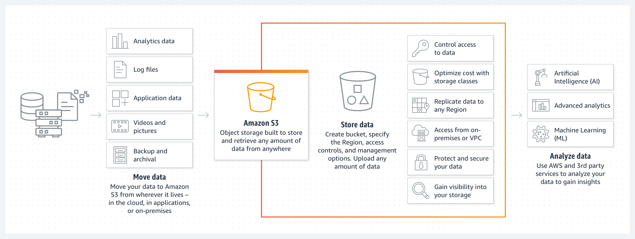

**WORKING WITH S3 IN PYTHON USING BOTO3**

**How to connect to S3 using Boto3?**

The Boto3 library provides you with two ways to access APIs for managing AWS services:

* The client that allows you to access the low-level API data. For example, you can get access to API response [data in JSON format](https://hands-on.cloud/how-to-process-json-data-in-python/).
* The resource that allows you to use AWS services in a higher-level object-oriented way. For more information on the topic, take a look at [AWS CLI vs. botocore vs. Boto3](https://hands-on.cloud/introduction-to-boto3-library/#aws-cli-vs-botocore-vs-boto3).

Here’s how you can instantiate the Boto3 client to start working with Amazon S3 APIs:

**How to create S3 bucket using Boto3?**

To avoid various exceptions while working with the Amazon S3 service, we strongly recommend you to define a specific AWS Region for the Boto3 client and S3 Bucket Configuration:

**Listing S3 Buckets using Boto3 client**

Here’s an example of listing existing S3 Buckets using the S3 resource:

**Deleting S3 Buckets using Boto3 client**

Here’s an example of deleting the Amazon S3 bucket using the Boto3 client

**Uploading a file to S3 Bucket using Boto3**

The upload_file() method requires the following arguments:

* file_name – filename on the local filesystem
* bucket_name – the name of the S3 bucket
* object_name – the name of the uploaded file (usually equals to the file_name)

Here’s an example of uploading a file to an S3 Bucket:

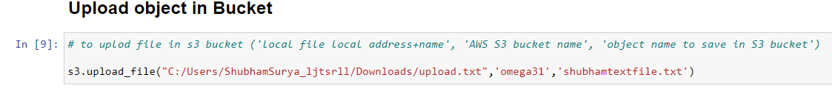

**Downloading a file from S3 Bucket using Boto3**

You can use the download_file() method to download the S3 object to your local file system:

**Like wise we can do many things with boto3 as follows.**

## How to rename S3 file object using Boto3?

## How to delete S3 objects using Boto3?

## How to read files from the S3 bucket into memory?

## How to copy file objects within S3 bucket using Boto3?

## How to create S3 Bucket Policy using Boto3?

### How to delete S3 Bucket Policy using Boto3?

## How to generate S3 presigned URL?

## How to enable S3 Bucket versioning using Boto3?